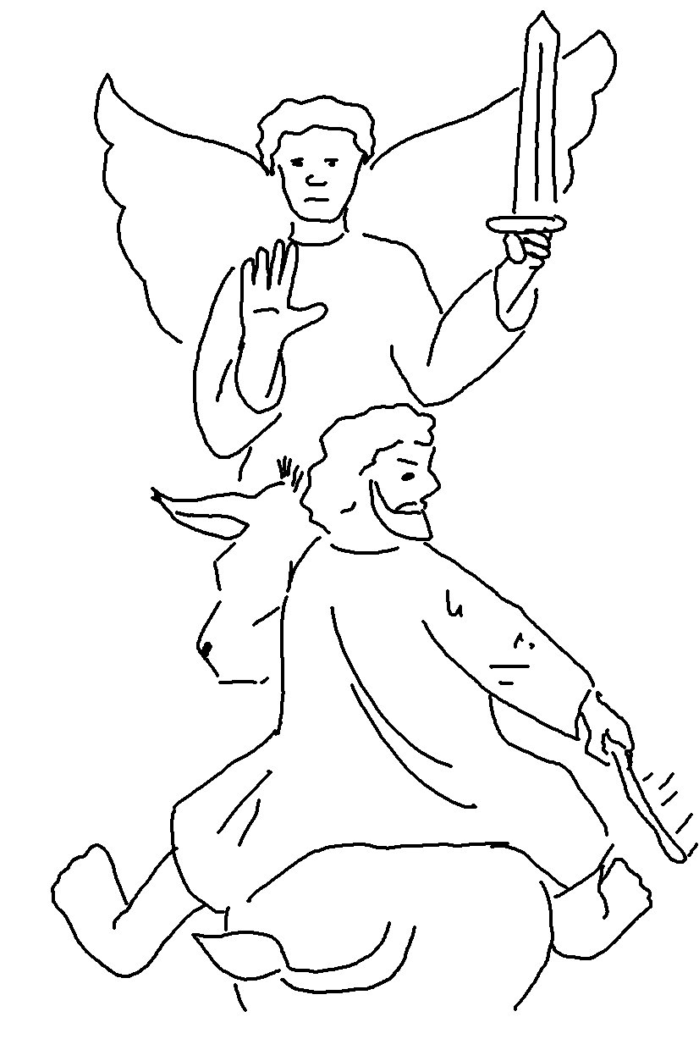
Choose a _ _ _ _ _ _ _ _ _ _ _ _ _ _ over great riches.
Proverbs 22:1_{NLT}

